# Preguntas Objetivo 5

Pregunta 1

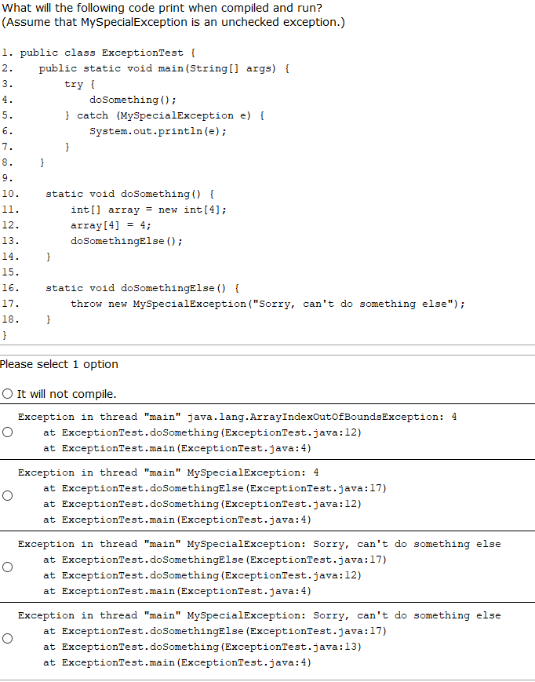

Pregunta 2

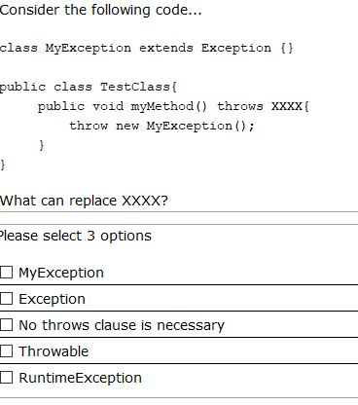

Pregunta 3

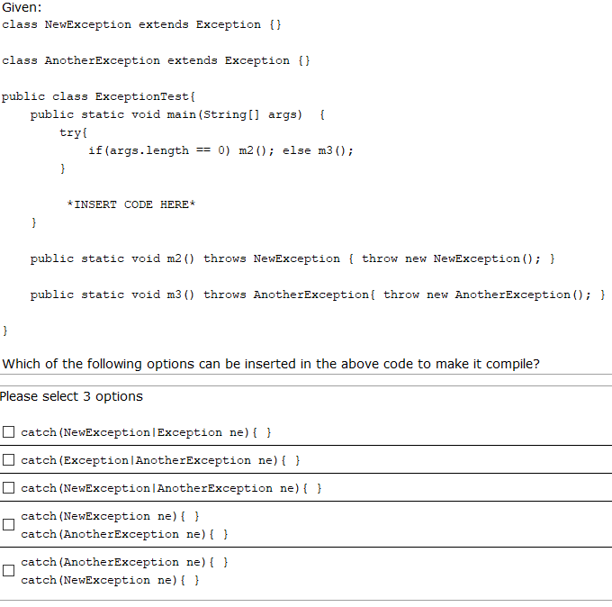

Pregunta 4

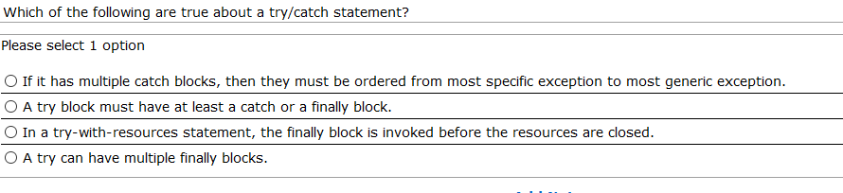

Pregunta 5

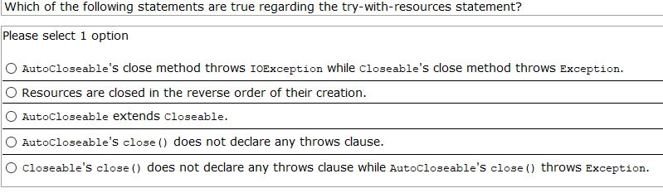

Pregunta 6

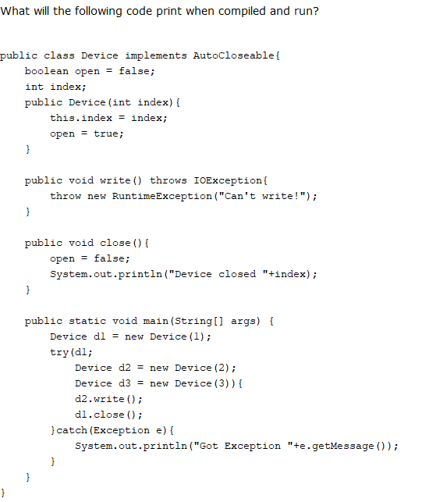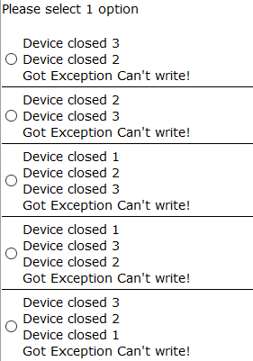

Pregunta 7

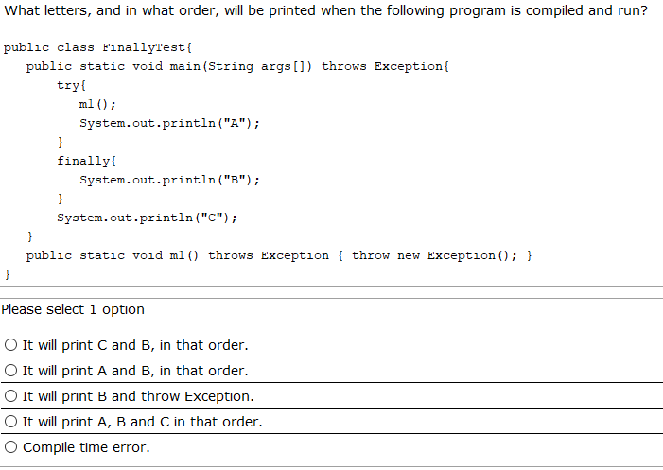

Pregunta 8

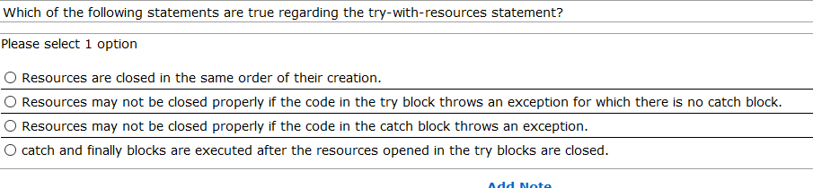

Pregunta 9

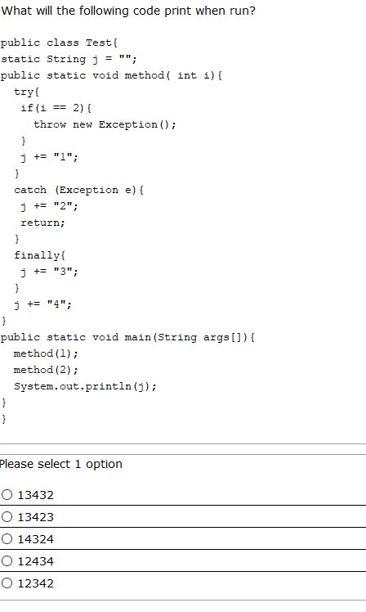

Pregunta 10

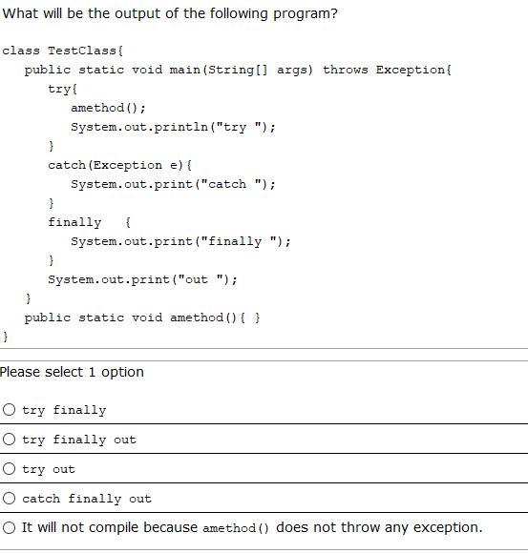

Pregunta 11

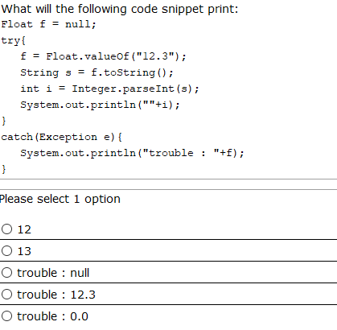

Pregunta 12

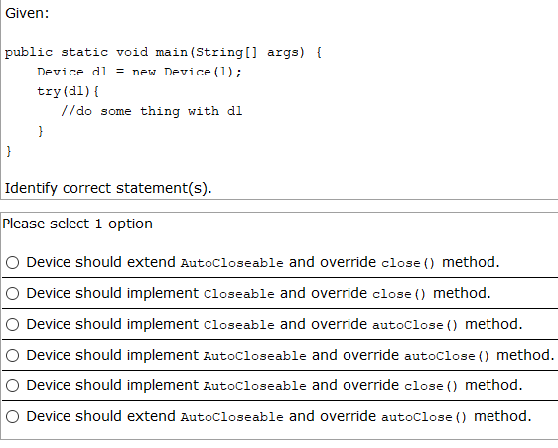

Pregunta 13

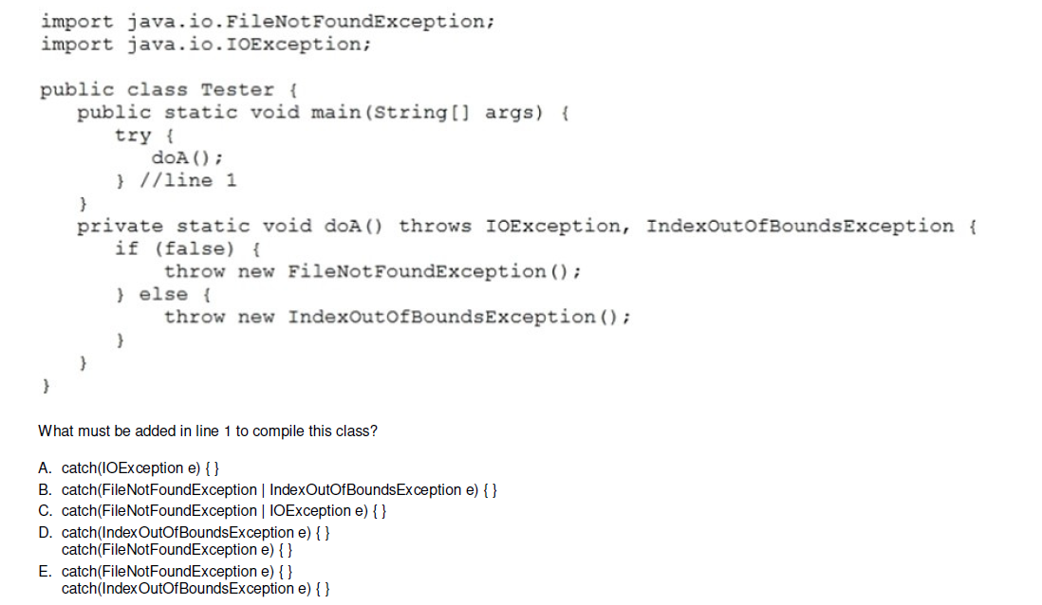

Pregunta 14

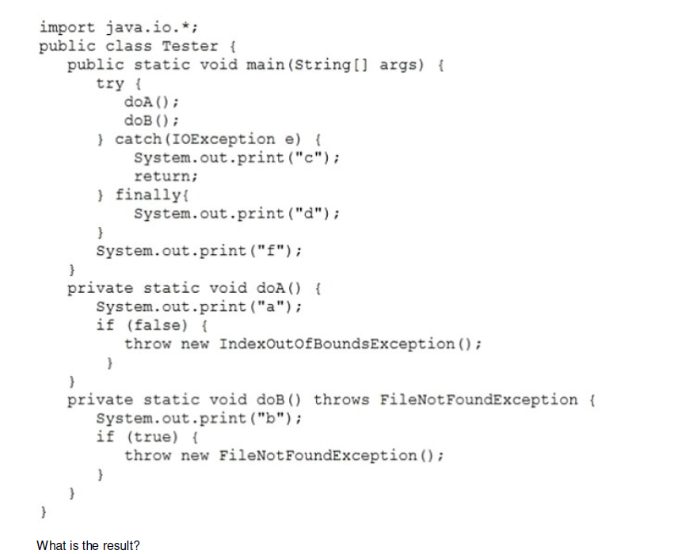

A. The compilation fails.

B. abdf

C. abd

D. adf

E. abcd

**Pregunta 15**

Given:

**public** **class** Test {

**static** **int** *d*=0;

**public** **static** **void** main(String[] args) {

*operation*("3w");

}

**static** **void** operation(String number) {

**int** n;

**int** oper;

**try** {

n=Integer.*parseInt*(number);

oper=n/d;

System.***out***.println(oper);

}

**catch**(NumberFormatException ex) {

System.***out***.println("Error in format");

*operation*("3");

}

**catch**(ArithmeticException ex) {

System.***out***.println("Error in operation");

*d*=1;

**return**;

}

**finally** {

System.***out***.println("completed");

}

}

}

What will it print?

1. Error in format

completed

1. Error in operation

completed

1. Error in format

Error in operation

completed

1. Error in format

Error in operation

completed

completed

1. Error in format

Error in operation

3

**Pregunta 16**

Which of the following are checked exceptions? (choose 3)

1. ClassNotFoundException
2. NumberFormatException
3. ClassCastException
4. SQLException
5. InterruptedException
6. IllegalArgumentException